**Linear Regression with One Variable**

* Model representation:

$$h_{θ}\left(x\right)=θ_{0}+θ_{1}x$$

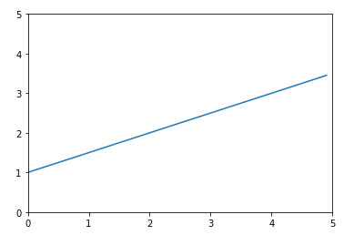

* Cost function intuition:

Hypothesis:

$$h_{θ}\left(x\right)=θ_{0}+θ_{1}x$$

Parameters:

$$θ_{0}, θ_{1}$$

Cost Function:

$$J\left(θ_{0},θ_{1}\right)=\frac{1}{2m}\sum_{i=1}^{m}{{\left(h_{θ}\left(x^{\left(i\right)}\right)-y^{\left(i\right)}\right)}^{2}}$$

$$=\frac{1}{2m}\sum_{i=1}^{m}{{(\left(\begin{aligned}1, x^{\left(1\right)} \\ 1, x^{\left(2\right)} \\ … \\ 1, x^{\left(m\right)}\end{aligned}\right)\left(\begin{aligned}θ_{0} \\ θ_{1}\end{aligned}\right)-\left(\begin{aligned}y^{\left(1\right)} \\ y^{\left(2\right)} \\ … \\ y^{(m)}\end{aligned}\right))}^{2}}$$

Goal:

$${minimize}_{θ_{0},θ_{1}} J(θ_{0},θ_{1})$$

* Gradient descent:

$$h_{θ}\left(x\right)=θ_{0}+θ_{1}x$$

$$J\left(θ_{0},θ_{1}\right)=\frac{1}{2m}\sum_{i=1}^{m}{{(h_{θ}\left(x^{\left(i\right)}\right)-y^{(i)})}^{2}}$$

$$=\frac{1}{2m}\sum_{i=1}^{m}{{(\left(θ_{0}+θ_{1}x^{\left(i\right)}\right)-y^{(i)})}^{2}}$$

$$=\frac{1}{2m}({\left(\left(θ_{0}+θ_{1}x^{\left(1\right)}\right)-y^{(1)}\right)}^{2}+{\left(\left(θ_{0}+θ_{1}x^{\left(2\right)}\right)-y^{(2)}\right)}^{2}+…+{(\left(θ_{0}+θ_{1}x^{\left(m\right)}\right)-y^{(m)})}^{2})$$

$$→\frac{∂J}{∂θ_{0}}=\frac{1}{2m}(2\left(\left(θ_{0}+θ_{1}x^{\left(1\right)}\right)-y^{\left(1\right)}\right)+2\left(\left(θ_{0}+θ_{1}x^{\left(2\right)}\right)-y^{\left(2\right)}\right)+…+2(\left(θ_{0}+θ_{1}x^{\left(m\right)}\right)-y^{(m)}))$$

$$=\frac{1}{m}(\left(\left(θ_{0}+θ_{1}x^{\left(1\right)}\right)-y^{\left(1\right)}\right)+\left(\left(θ_{0}+θ_{1}x^{\left(2\right)}\right)-y^{\left(2\right)}\right)+…+(\left(θ_{0}+θ_{1}x^{(m)}\right)-y^{(m)}))$$

$$=\frac{1}{m}(\left(h_{θ}\left(x^{\left(1\right)}\right)-y^{\left(1\right)}\right)+\left(h_{θ}\left(x^{\left(2\right)}\right)-y^{\left(2\right)}\right)+…+(h_{θ}\left(x^{\left(m\right)}\right)-y^{(m)}))$$

$$=\frac{1}{m}\sum_{i=1}^{m}{(h_{θ}\left(x^{\left(i\right)}\right)-y^{(i)})}$$

$$=\frac{1}{m}\sum_{i=1}^{m}{({\left({1, x_{1} \atop \begin{aligned}1, x_{2} \\ … \\ 1, x_{m}\end{aligned}}\right)}_{m*2}{\left(\begin{aligned}θ_{0} \\ θ_{1}\end{aligned}\right)}_{2*1}-\left(\begin{aligned}y_{1} \\ y_{2} \\ … \\ y_{m}\end{aligned}\right))}$$

$$→\frac{∂J}{∂θ_{1}}=\frac{1}{2m}(2\left(\left(θ_{0}+θ_{1}x^{\left(1\right)}\right)-y^{\left(1\right)}\right)x^{(1)}+2\left(\left(θ_{0}+θ_{1}x^{\left(2\right)}\right)-y^{\left(2\right)}\right)x^{(2)}+…+2(\left(θ_{0}+θ_{1}x^{\left(m\right)}\right)-y^{(m)})x^{(m)})$$

$$=\frac{1}{m}(\left(h_{θ}\left(x^{\left(1\right)}\right)-y^{\left(1\right)}\right)x^{(1)}+\left(h_{θ}\left(x^{\left(2\right)}\right)-y^{\left(2\right)}\right)x^{(2)}+…+(h_{θ}\left(x^{\left(m\right)}\right)-y^{(m)})x^{(m)})$$

$$=\frac{1}{m}\sum_{i=1}^{m}{(h_{θ}\left(x^{\left(m\right)}\right)-y^{(m)})x^{(i)}}$$

$$=\frac{1}{m}\sum_{i=1}^{m}{({\left({1, x_{1} \atop \begin{aligned}1, x_{2} \\ … \\ 1, x_{m}\end{aligned}}\right)}_{m*2}{\left(\begin{aligned}θ_{0} \\ θ_{1}\end{aligned}\right)}_{2*1}-\left(\begin{aligned}y_{1} \\ y_{2} \\ … \\ y_{m}\end{aligned}\right))\left(\begin{aligned}x_{1} \\ x_{2} \\ … \\ x_{m}\end{aligned}\right)}$$

Repeat until convergence:

$$θ_{j}≔θ_{j}-α\frac{∂}{∂θ_{j}}J\left(θ_{0},θ_{1}\right), for j=0 and j=1$$

**Implementation in Python:**

Source data (rows = 97, columns = 2):

|  |  |
| --- | --- |
| **X** | **Y** |
| 6.1101 | 17.592 |
| 5.5277 | 9.1302 |
| 8.5186 | 13.662 |
| 7.0032 | 11.854 |
| 5.8598 | 6.8233 |
| 8.3829 | 11.886 |
| 7.4764 | 4.3483 |
| 8.5781 | 12 |
| 6.4862 | 6.5987 |
| 5.0546 | 3.8166 |

Load data

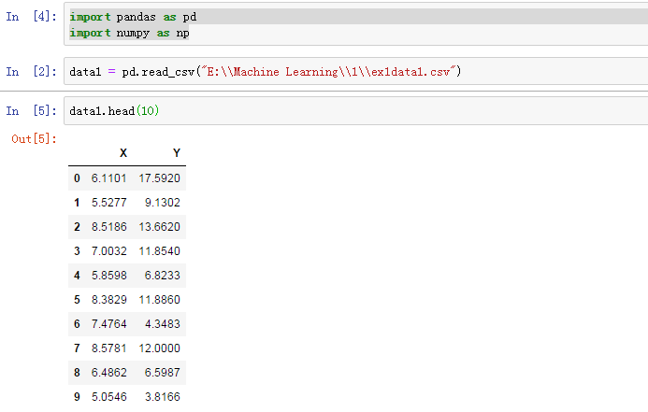

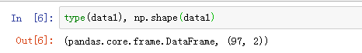

Visualize data

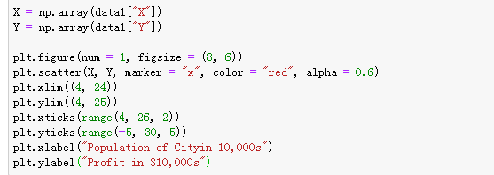

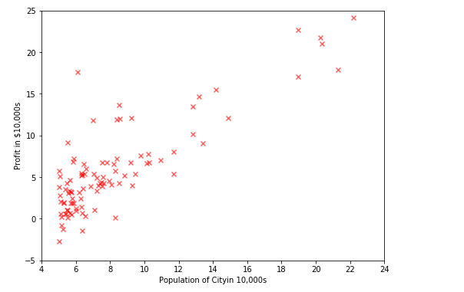

**Cost and Gradient Descent**

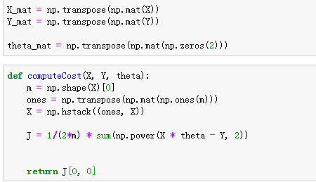

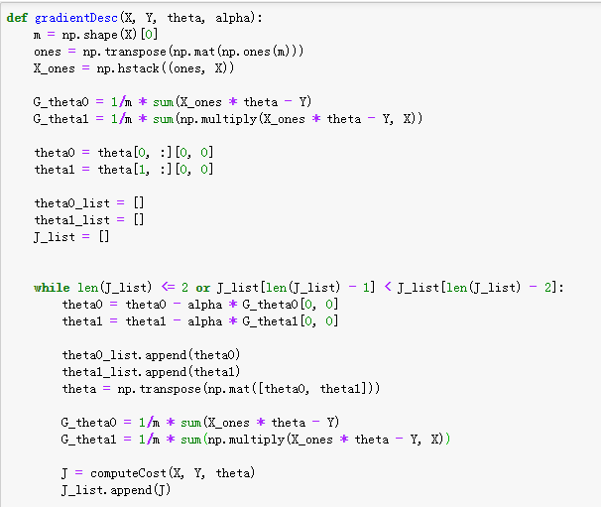



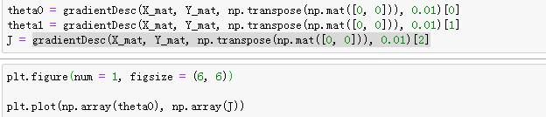

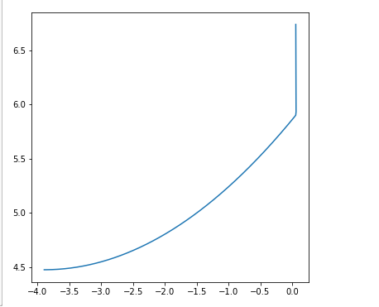

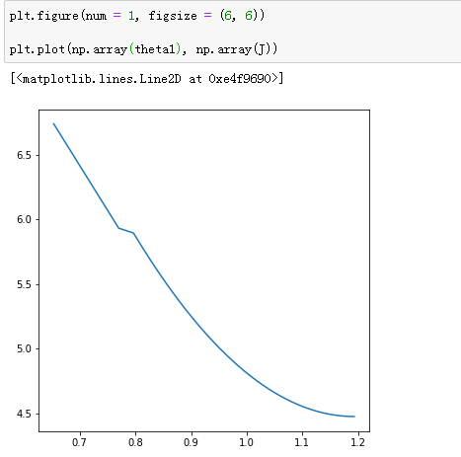

**Prediction**

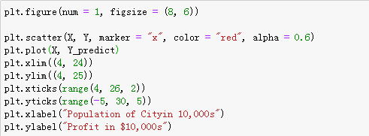

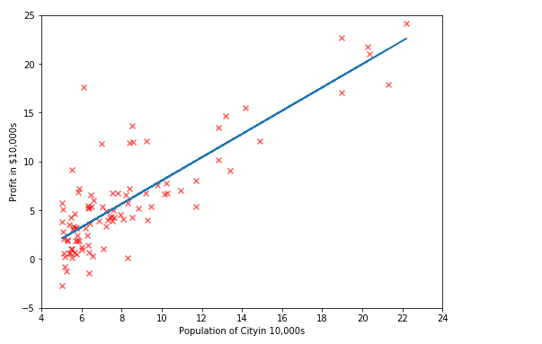

**Case Study --- Predict House Prices (Coursera)**